# **User Interface Lab 5 (Group 27)**

15 Feb 2024

## Group Members

* Dylan Toh
* Wong Jia Kang
* Andy Low

## Each Member Contributions

Andy:

Helped with index.html (Lines 272-302)

Dylan:

Helped with the researching on JQuery, relating to how we can integrate it into our HTML/CSS/JS scripts

Jia Kang:

Helped with the main.js script (Lines 26-36) and index.html (Lines 272-302)

## Link to Website

<https://seg3125-a.github.io/Group-27/Lab5/>

## Snapshots of website created (same as Lab 4). See last pic for add-on for Lab 5







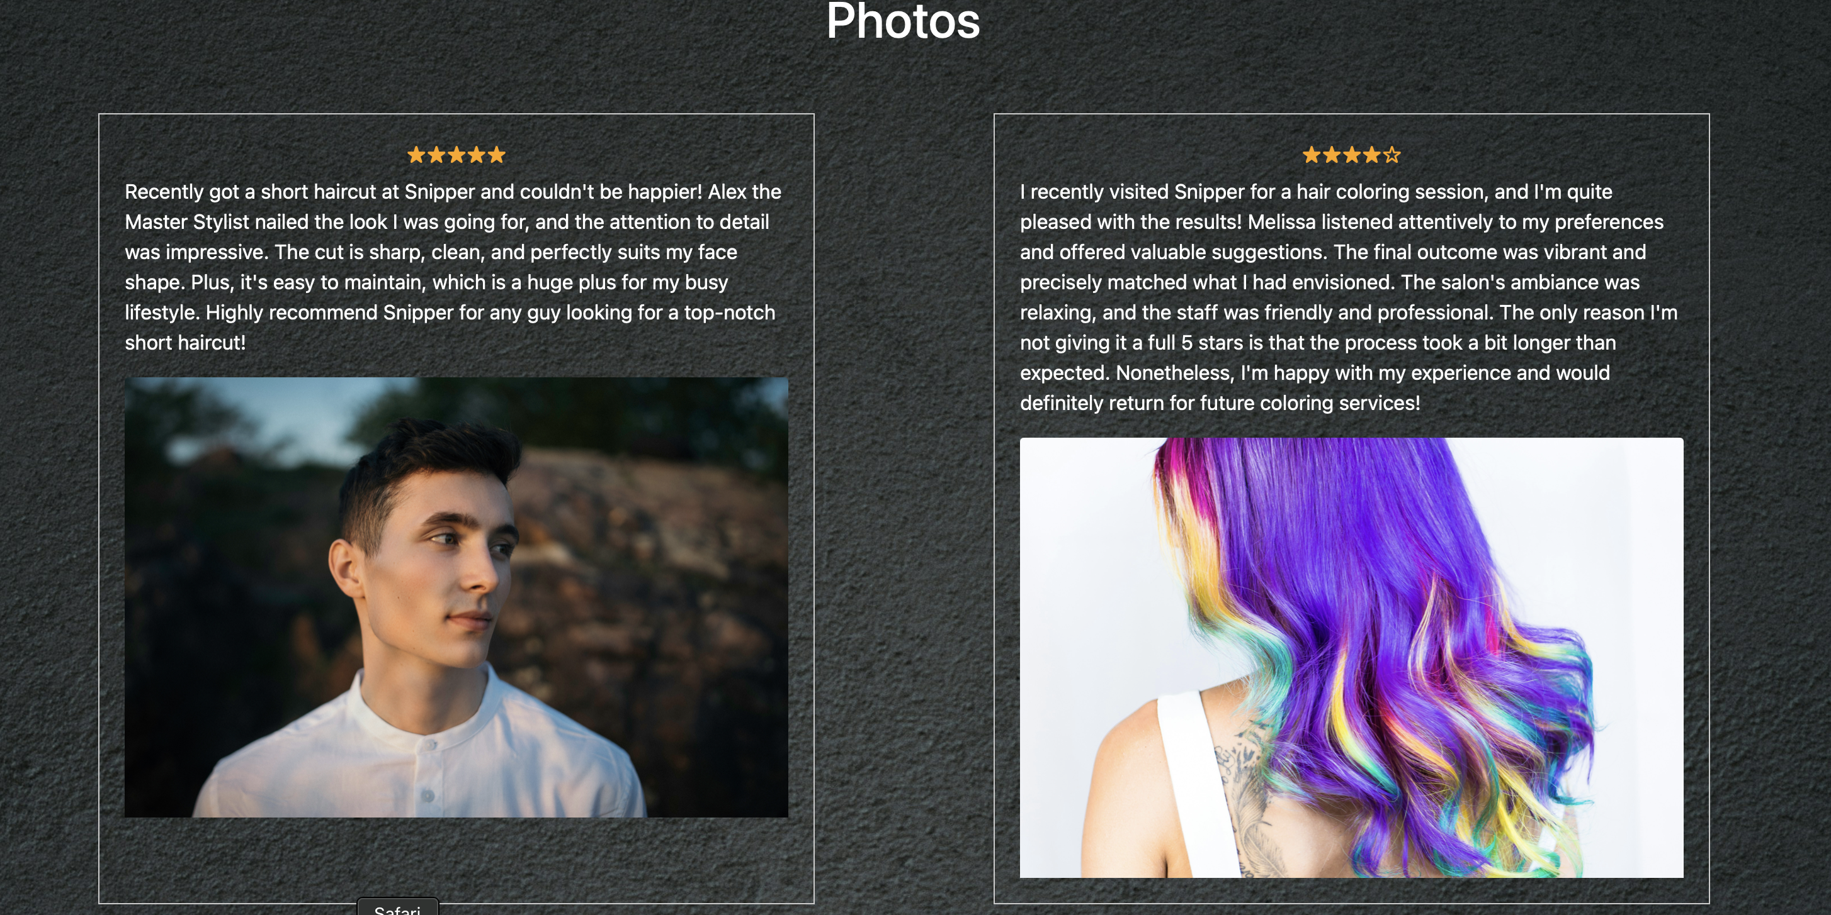

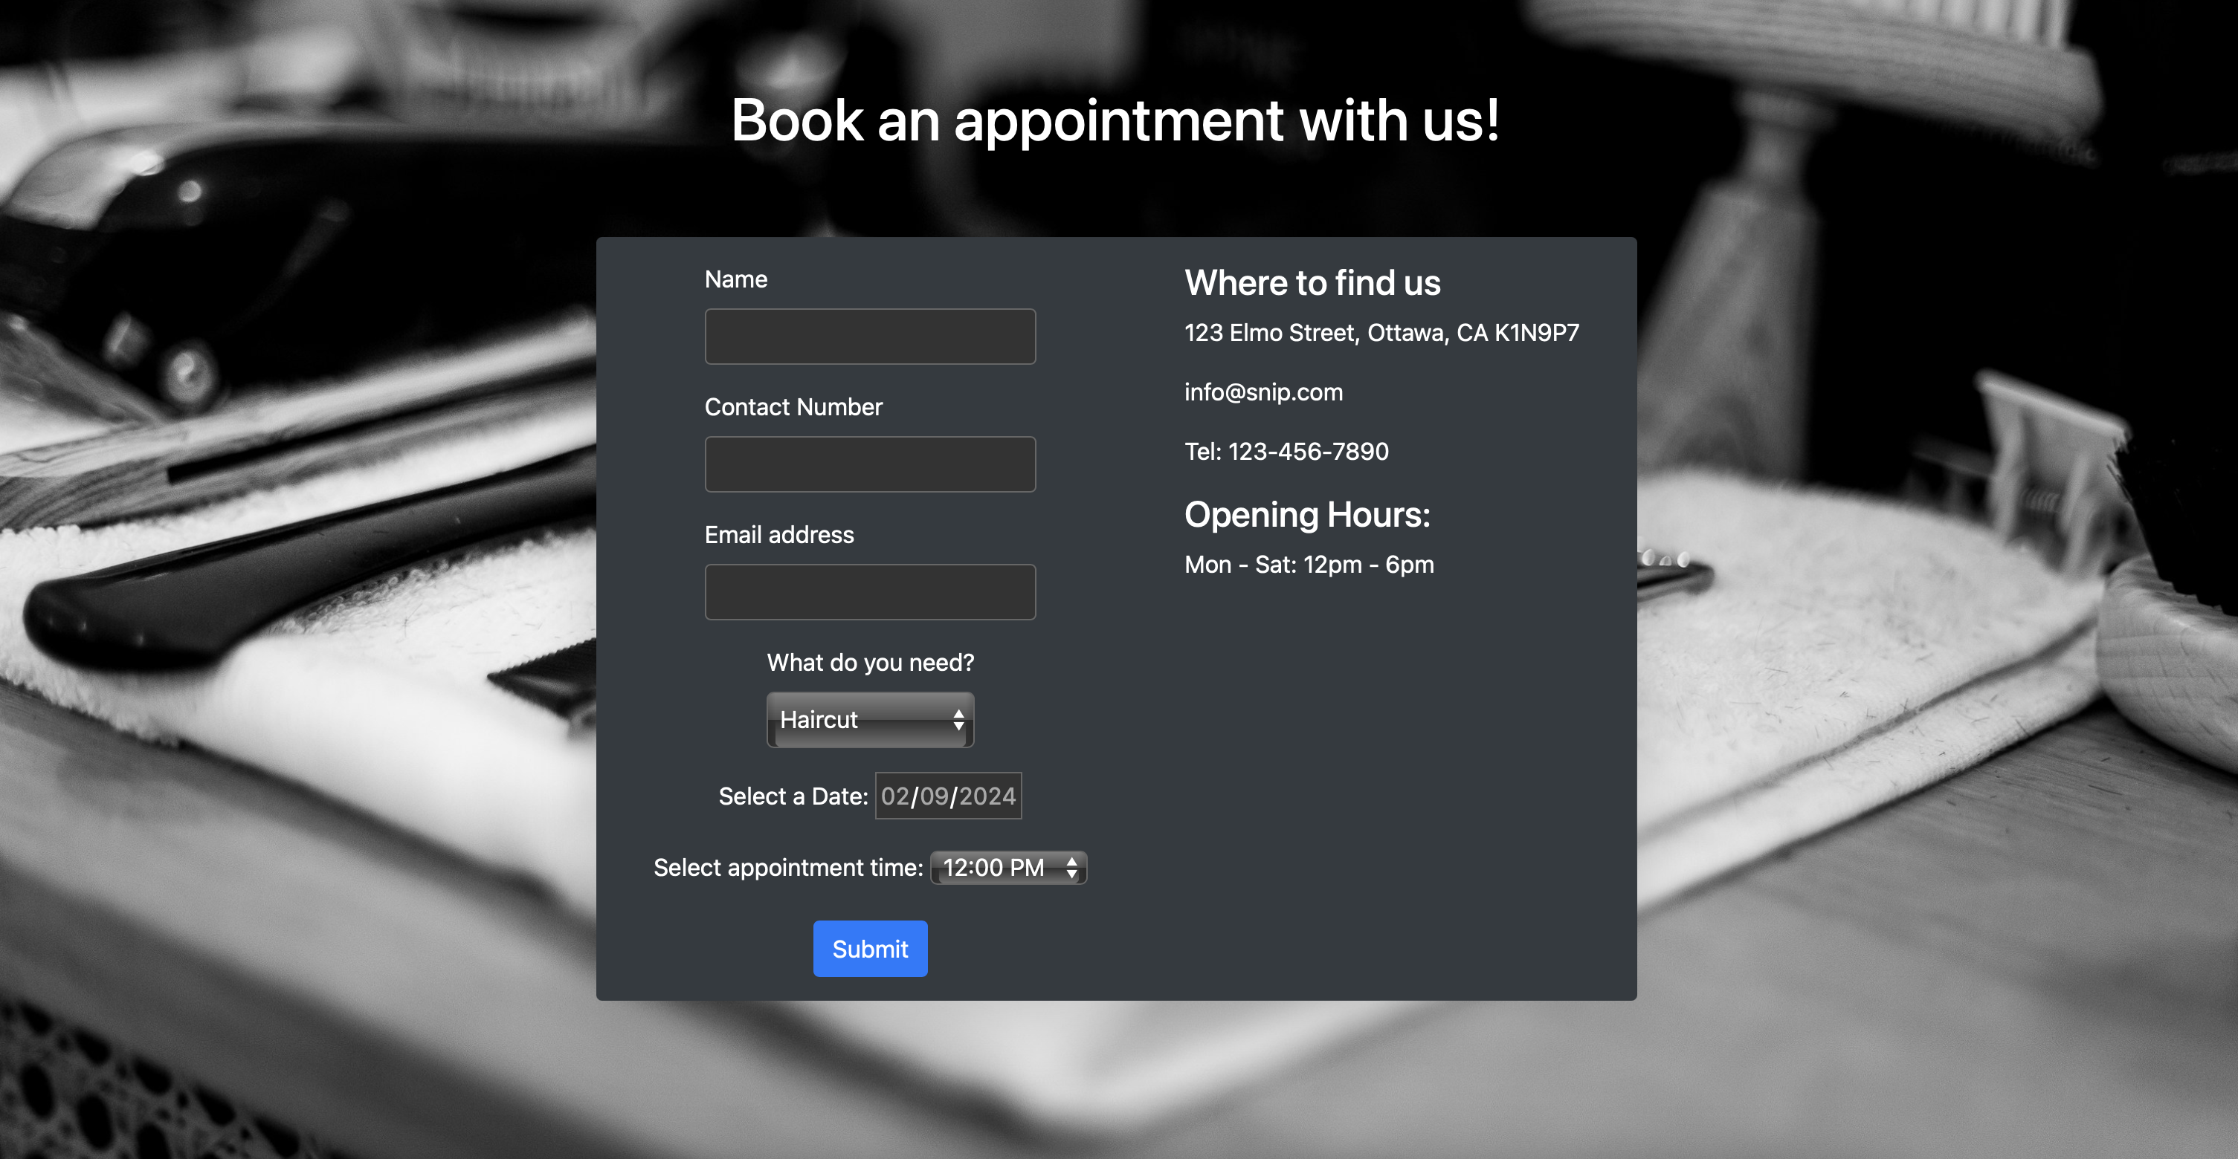

## Add-on for Lab 5

